Magnetic modeling for 3-D Shapes of Homogeneous dipole distribution

The equation for finding the magnetic field from a dipole is: [1]

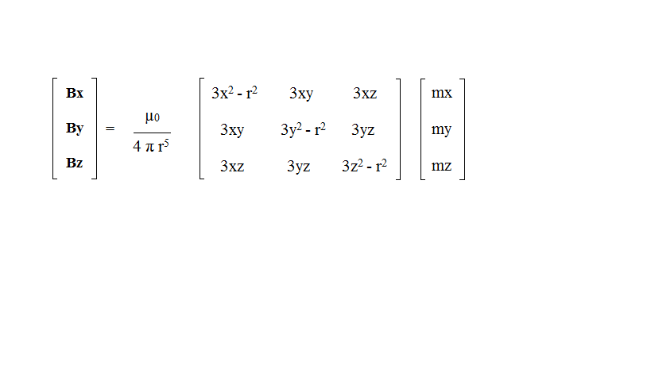

(1)

where r = √(x2 + y2 + z2), x, y, z, are the vector components of the distance from the dipole source to the point at which the field is measured, mx, my and mz are the vector components of the magnetic dipole moment and µ0 is permeability of free space.

**Realization for a Model**:

The approach is based on magnetic signature modeling of a magnetic cube assuming the absence of Earth Magnetic Field or any other external magnetic field. The magnetic field present is purely due to the Permanent Magnetism of the cube, no Induced Magnetism is present. The cube is meshed and has magnetic dipoles located at intersection of the mesh lines. The meshed cube moves along X-direction at particular distance of offset along negative Z-direction. The center line of division which divides the cube in the YZ-plane into two equal halves is aligned with the –Z axis, hence one half portion of the cube lies along –Y –axis and other on the +Y -axis. The alignment of 3-axes is shown in Fig. 2.5.

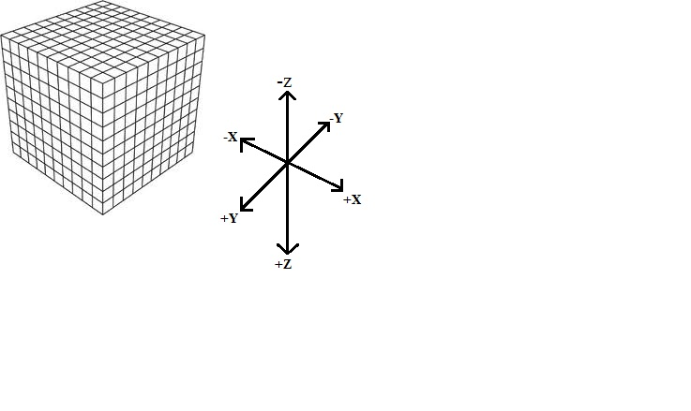

Fig. 2.5 – Meshed cube along 3-axes

The distances x, y and z for each dipole is measured from a point of observation which is located at the origin from certain distance in X-direction. The moves along the X-axis from negative to positive cross-passing the origin (observation point) at certain offset along negative Z-axis. The cube has homogenous distribution of dipole moment, comprising of equal dipole moment **mx**, **my** and **mz** throughout its space in all three directions (X, Y and Z). A magnetic sensor placed at the origin measures the magnetic field of the cube at the origin which is the summation of the magnetic field produced by all magnetic dipole moments. The magnetic field in all three directions **Bx, By** and **Bz** at the origin due to the cube is calculated using equation (1).

**The Block diagram for generation of Model is as follows**:-

Measure distance of dipole in 3D

Calculate the resultant ‘r’

Calculate terms in 3x3 Matrix of equation 1

Use values of mx, my, and mz to calculate Bx, By and Bz

Plot Bx, By and Bz against iteration along X-axis

Collect all Bx, By and Bz for iteration along X-axis

Block Diagram of Model

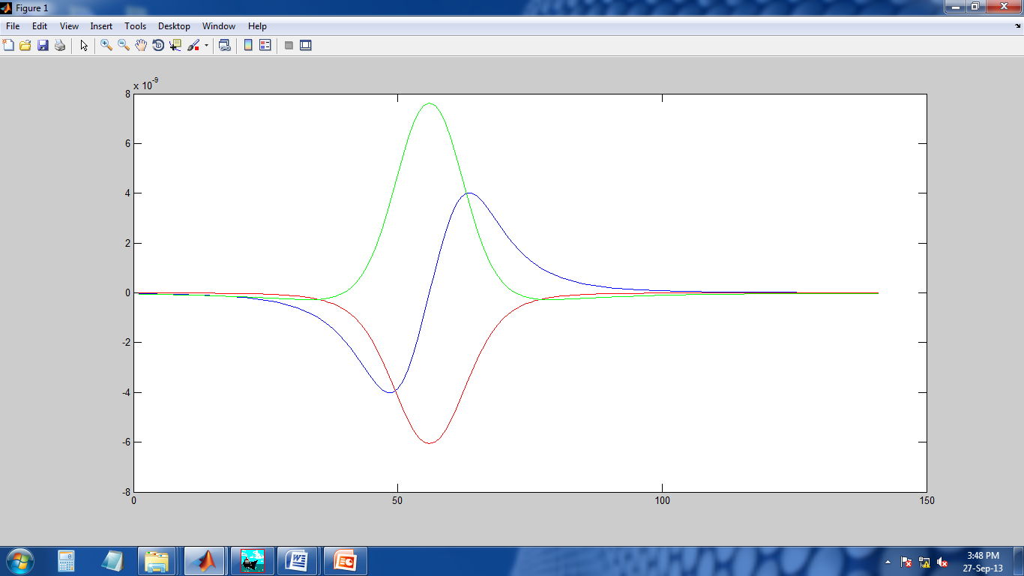

Bx: Blue line

By: Red line

Bz: Green line

**References**:

[1]Magnetic Modeling Techniques by Dr. G J Webb – Ultra Electronics, Canncock, Staffordshire, UK.